**Marisa Loraas**

**CSE 326: Software Engineering**

**2nd Assignment- Requirement Engineering**

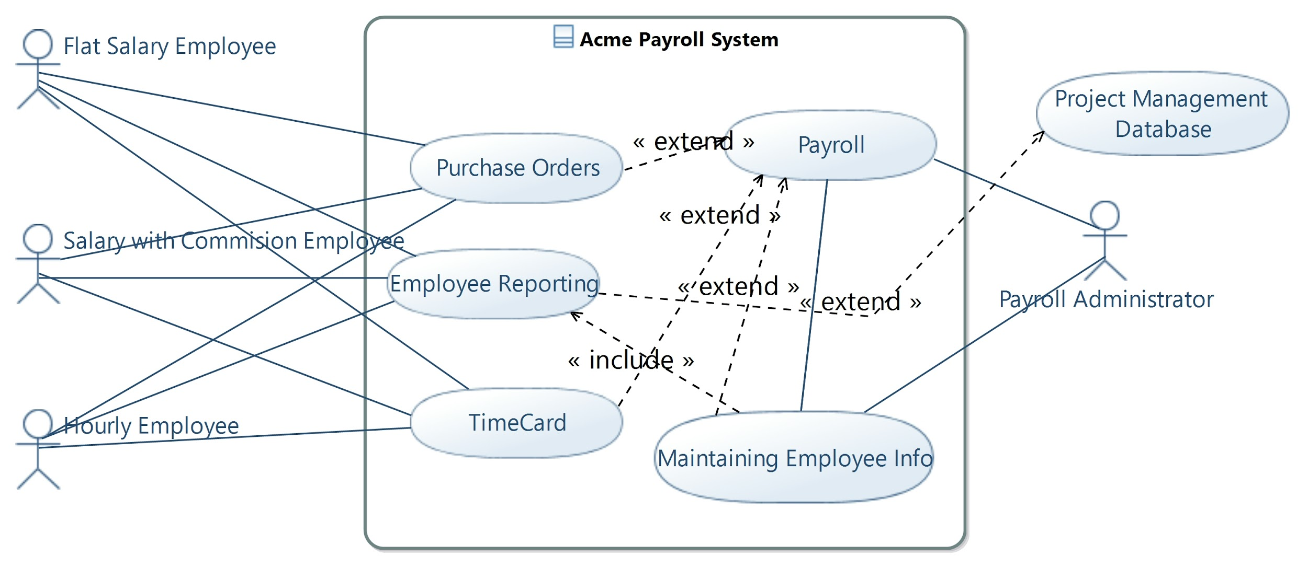

In this use case diagram, I represent the Acme Payroll system with four main influencing actors: the payroll administrator, flat salary employees, salary with commission employees and hourly employees. Payroll administrator interacts with the payroll use case and the maintaining employee info use case. Other employees interact with the purchase orders, employee reporting, and time card use cases. These use cases interact with each other, the actors, and reference the project management database to make the payroll system operational.

1. **Payroll**
   1. **Brief Description**

This use case is invoked by the Payroll administrator to appropriately pay employees on a given date and generate payment records for employees on these specified dates.

* 1. **Flow of Events**
     1. *Basic Flow*

This use case starts when an administrator runs payroll on a payday

1. On the date specified to the system by the administrator to run payroll, the system will pay employees the appropriate amount based on their maintained employee information with the appropriate method of payment as well.
2. Once this is done, the system will also generate a payment records for all employees with the last time they were paid
   * + 1. Accessing Employee Information
3. The use case requires access to the maintained employee information and reported hours worked in order to appropriately pay employees. The use case needs access to the following for each employee:

* Name
* Employee Type
* Mailing address
* Hourly Rate
* Salary
* Commission Rate
* Hour Limit
* Hours Worked
* Payment Method
* Employee Purchase Orders
  + - 1. Paying Employees

1. The subsystem will pay employees based on the three employee types:

* Hourly employees receive an hourly pay rate, based on the hours they worked for this pay date. They also receive 1.5 times their pay rate for every hour they work past 8 in a day, unless they have surpassed their hour limit.
* Flat salary employees are paid a flat salary on the last working day of the month.
* Commission salary employees receive a salary just as a flat salary employee but they also receive a commission that is determined from their submitted purchase orders for the pay period and the determined commission rate: 10%, 15%, 25%, or 35%.

1. The subsystem will also pay employees based on their choice of payment method, the system will either approve for checks to be mailed to the postal address of their choice or direct deposit their check into the account of their choosing.
   * + 1. Generating Payment records
2. After a payment has been processed the system will generate the payment record for the employee for the specified date given by the system administrator and the necessary payment information.
3. If this is the last payment, indicated by the employee record, than the system will also delete the employee from the system
   * 1. *Alternative Flow*
        1. Date Not Specified

If a Payroll Administrator tries to run payroll without giving the date for payment records, the subsystem will display a message asking the administrator to add the date.

* + - 1. Failed Deposit

If the system receives word that the bank is unable to process a deposit into the employee(s) account, the subsystem will retry to submit the transaction after a specified period of time.

* 1. **Special Requirements**

None

* 1. **Pre-Conditions**

Payroll Administrator must be logged on the system before this use case begins and it must be a payday: a Friday or on the last working day of the month

* 1. **Post-Conditions**

If the use case was successful, all employees will have been paid properly and payment records and paid employees will have been updated. Otherwise, the system state is unchanged.

* 1. **Extension Points**

None

Sequence Diagram Below: The sequence diagram on the following page shows the user interaction with the Maintain Employee Information aspect of the system, and how each function(AddEmployee, DeleteEmployee, and UpdateEmployee) all request and display information to the payroll administrator.

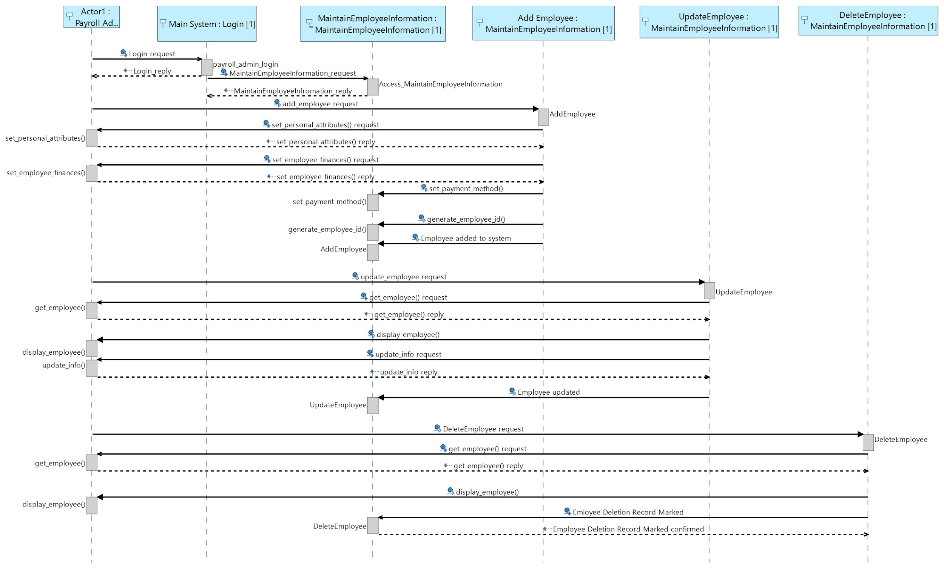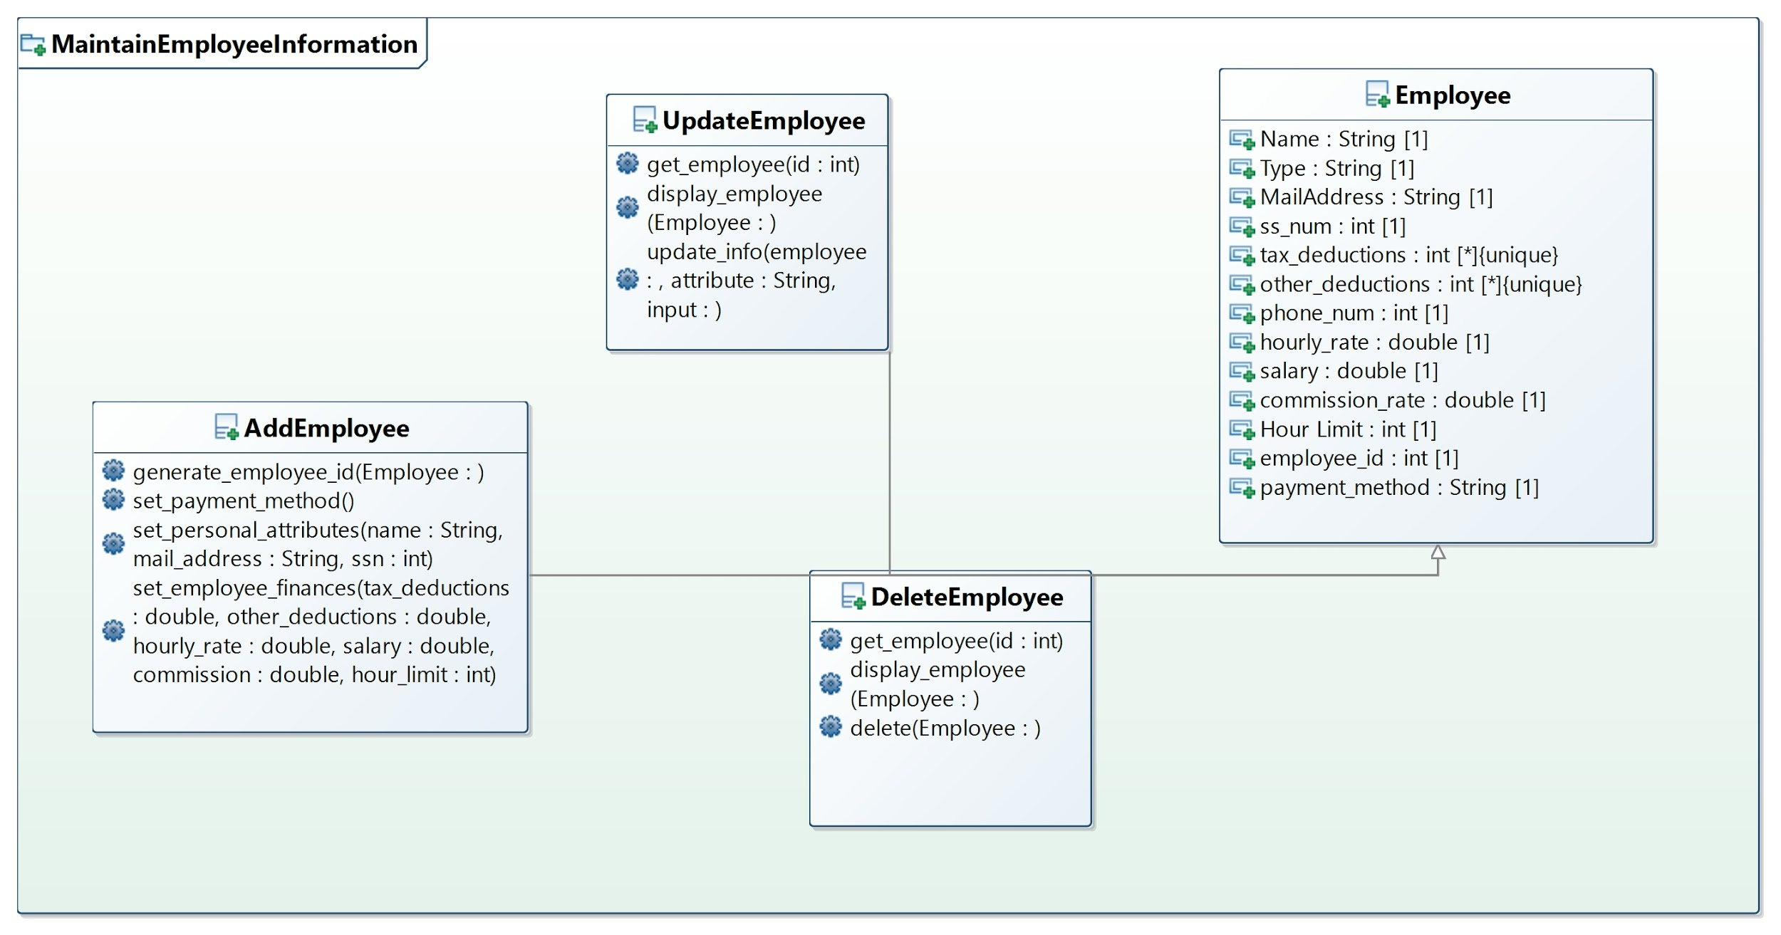

The above class diagram represents the classes available in the MaintainEmployeeInformation use case. I tried to make the Employee class a data type or enumeration but was having difficulties with it displaying features so please be lenient when observing that. The UpdateEmployee, AddEmployee, and DeleteEmployee classes all reference the structure existing for storing employee information and does its various function based on invocation.